**Information Analysis and Visualisation(COMP1844)**

coursework_Pham Thanh Truc_GCD220368_001308734

Table of Contents

Task 1 2

Code 2

Plot 5

Task 2 6

Code 6

Plot 13

Task 3 15

Code 15

Explain the math 16

Result 17

# Task 1

## Code

The code was explained in detail by comments

import **pandas** as **pd** *# Importing pandas library for data manipulation and analysis*

import **networkx** as **nx** *# Importing NetworkX library for creating and manipulating complex networks*

import **matplotlib**.**pyplot** as **plt** *# Importing Matplotlib library for plotting graphs*

from **matplotlib**.**lines** import **Line2D** *# Importing Line2D class from Matplotlib for creating custom legend elements*

import **requests** *# Importing requests library for making HTTP requests*

*# Function to get distance between two locations using GraphHopper*

def **get_distance**(from_place, to_place, api_key):

"""

Fetch distance between two coordinates using the GraphHopper API.

Args:

- from_place (str): Coordinates of the starting point as "lat,lon".

- to_place (str): Coordinates of the destination as "lat,lon".

- api_key (str): Your GraphHopper API key.

Returns:

- float: Distance in kilometers, rounded to two decimal places.

"""

*# Constructing the URL for the GraphHopper API request*

url = f"https://graphhopper.com/api/1/route?point={from_place}&point={to_place}&vehicle=foot&locale=en&key={api_key}"

try:

*# Making the API request*

response = **requests**.**get**(url)

*# Raising an exception if the request was unsuccessful*

response.**raise_for_status**()

*# Parsing the JSON response*

data = response.**json**()

*# Checking if the response contains the 'paths' key and if it has at least one path*

if 'paths' in data and **len**(data['paths']) > 0:

*# Extracting the distance from the response and converting it from meters to kilometers*

distance = data['paths'][0]['distance'] / 1000

*# Returning the distance rounded to two decimal places*

return **round**(distance, 2)

except **requests**.**exceptions**.**RequestException** as e:

*# Printing an error message if there was a request exception*

**print**(f"Request error: {e}")

except **KeyError**:

*# Printing an error message if the response format was unexpected*

**print**(f"Unexpected API response format: {response.**json**()}")

*# Returning None if there was an error*

return None

*# Define stations and their positions (latitude, longitude)*

stations = {

'Hyde Park Corner': (51.5025, -0.1527), *# Coordinates for Hyde Park Corner*

'Green Park': (51.5067, -0.1428), *# Coordinates for Green Park*

'Piccadilly Circus': (51.5101, -0.1337), *# Coordinates for Piccadilly Circus*

'Leicester Square': (51.5115, -0.1280), *# Coordinates for Leicester Square*

'Covent Garden': (51.5133, -0.1240), *# Coordinates for Covent Garden*

'Holborn': (51.5171, -0.1195) *# Coordinates for Holborn*

}

*# Define connections (edges)*

connections = [

('Hyde Park Corner', 'Green Park'), *# Connection between Hyde Park Corner and Green Park*

('Green Park', 'Piccadilly Circus'), *# Connection between Green Park and Piccadilly Circus*

('Piccadilly Circus', 'Leicester Square'), *# Connection between Piccadilly Circus and Leicester Square*

('Leicester Square', 'Covent Garden'), *# Connection between Leicester Square and Covent Garden*

('Covent Garden', 'Holborn') *# Connection between Covent Garden and Holborn*

]

api_key = 'Your-GraphHopper-API-key' *# API key for GraphHopper*

*# Calculate distances and store them*

distances = {} *# Initializing an empty dictionary to store distances*

for u, v in connections:

*# Getting the distance between two stations*

distance = **get_distance**(f"{stations[u][0]},{stations[u][1]}", f"{stations[v][0]},{stations[v][1]}", api_key)

if distance is not None:

*# Storing the distance in the dictionary if it was successfully fetched*

distances[(u, v)] = distance

else:

*# Printing an error message if the distance could not be fetched*

**print**(f"Failed to fetch distance for: {u} -> {v}")

*# Create the network graph*

def **create_piccadilly_segment**():

*# Create a new directed graph*

G = **nx**.**Graph**() *# Initialize an empty undirected graph using NetworkX*

*# Add nodes (stations) with their geographical coordinates*

for station, pos in stations.**items**():

G.**add_node**(station, pos=pos) *# Add each station as a node with its coordinates as attributes*

*# Define connections with distances from the API or hardcoded values*

connections_with_distances = [

(u, v, distances.**get**((u, v), "N/A"))

for u, v in connections *# Create a list of connections with their distances*

]

*# Add edges (connections)*

for u, v, distance in connections_with_distances:

if distance != "N/A":

G.**add_edge**(u, v, weight=distance) *# Add an edge with the distance as weight if available*

else:

**print**(f"Skipping edge: {u} -> {v} due to missing data") *# Print a message if distance data is missing*

*# Create the plot*

**plt**.**figure**(figsize=(12, 6)) *# Create a new figure with specified size*

*# Get positions of the nodes*

pos = **nx**.**get_node_attributes**(G, 'pos') *# Get the positions of the nodes from the graph attributes*

*# Draw edges*

**nx**.**draw_networkx_edges**(G, pos, edge_color='#29338D', width=2) *# Draw the edges with specified color and width*

*# Draw nodes*

**nx**.**draw_networkx_nodes**(G, pos, node_color='#29338D', node_size=800) *# Draw the nodes with specified color and size*

*# Add station names below each node*

for node, (x, y) in pos.items():

**plt**.**text**(

x, y - 0.002, node, ha='center', va='center', fontsize=8,

color="black", bbox=**dict**(facecolor="none", edgecolor="none", boxstyle="round,pad=0.1")

) *# Add text labels for each node with specified formatting*

*# Add edge labels (distances)*

edge_labels = **nx**.**get_edge_attributes**(G, 'weight') *# Get the edge weights (distances) from the graph attributes*

formatted_labels = {k: f"{v}" for k, v in edge_labels.items() if v != "N/A"} *# Format the labels for display*

**nx**.**draw_networkx_edge_labels**(G, pos, edge_labels=formatted_labels, font_size=8,

bbox=**dict**(facecolor="white", edgecolor="none", boxstyle="round,pad=0.1")) *# Draw the edge labels*

*# Add key/legend*

legend_elements = [**Line2D**([0], [0], color="#29338D", lw=2, label="Piccadilly")] *# Create a legend element*

**plt**.**legend**(handles=legend_elements, loc='center left', bbox_to_anchor=(1, 0.5), fontsize=12,

frameon=True, framealpha=1, facecolor='white', edgecolor='black') *# Add the legend to the plot*

*# Set plot title*

**plt**.**title**("Piccadilly Line with Actual Distances in Km") *# Set the title of the plot*

**plt**.**axis**("off") *# Hide axes*

return **plt** *# Return the plot object*

*# Create and show the plot*

**plt** = **create_piccadilly_segment**() *# Call the function to create the plot*

**plt**.**tight_layout**() *# Adjust the layout to fit everything nicely*

**plt**.**show**() *# Display the plot*

## Plot

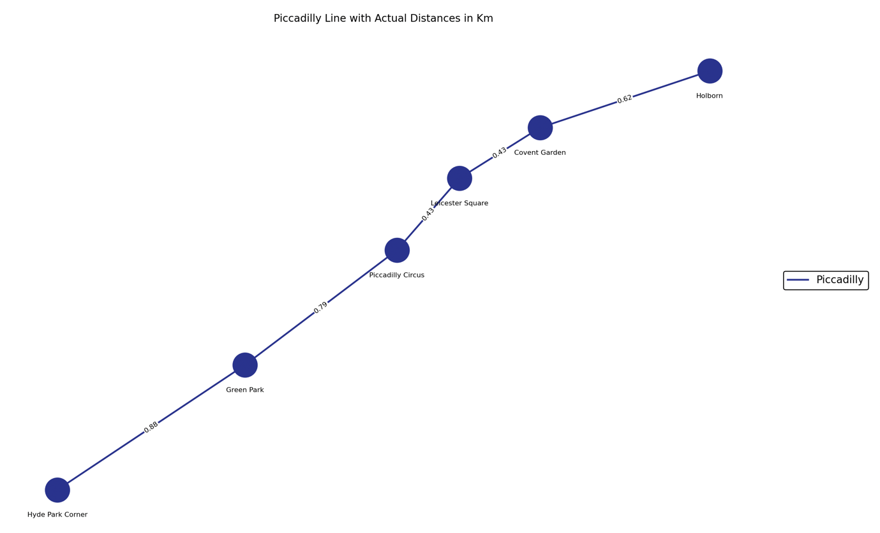

The plot was drawed by using actual positions so the route looks like on Google Maps

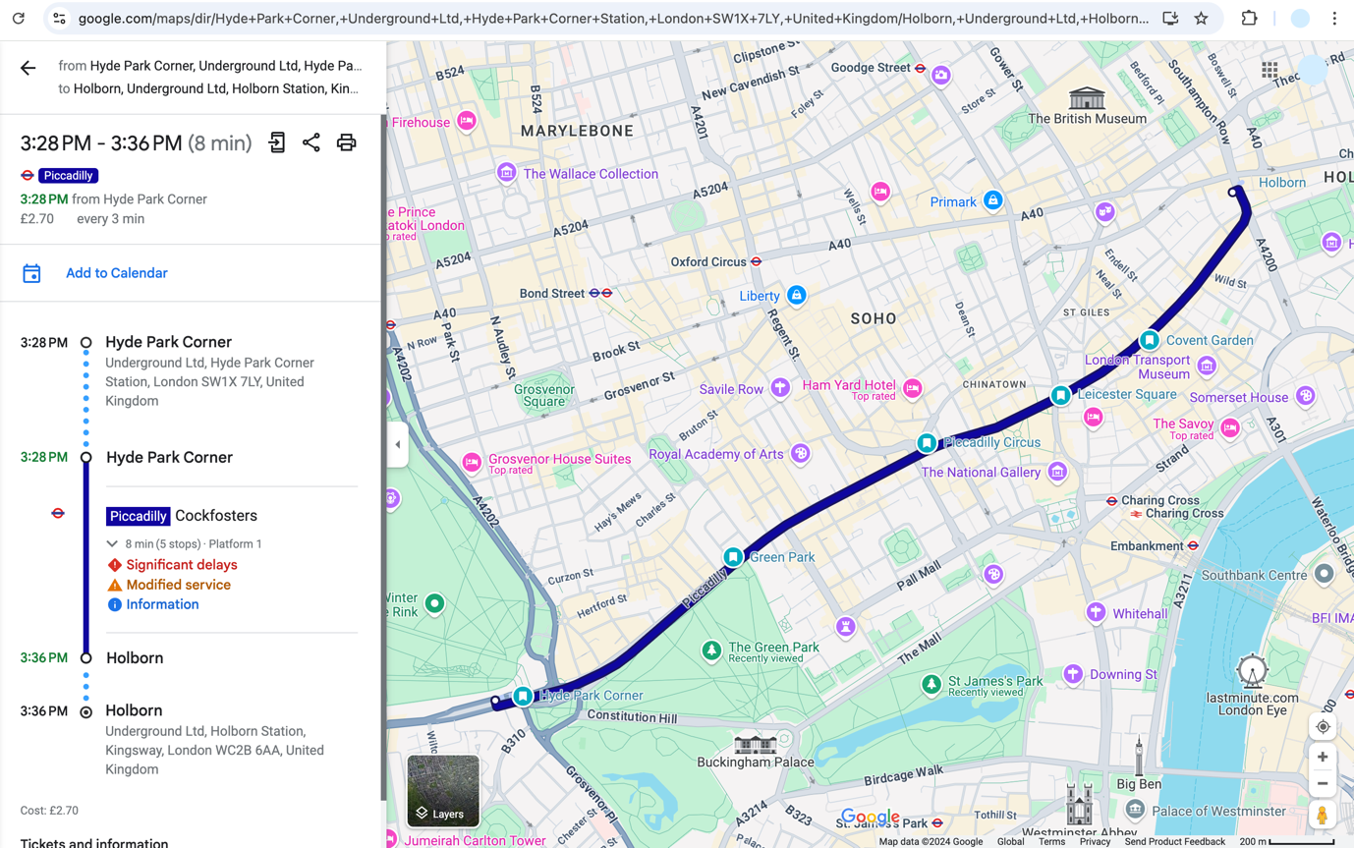

# Task 2

## Code

The code was explained in detail by comments.

import **pandas** as **pd** *# Importing pandas for data manipulation and analysis*

import **networkx** as **nx** *# Importing NetworkX for creating and manipulating complex networks*

import **matplotlib**.**pyplot** as **plt** *# Importing Matplotlib for plotting graphs*

import **requests** *# Importing requests for making HTTP requests to APIs*

from **matplotlib**.**lines** import **Line2D** *# Importing Line2D for custom legend creation in Matplotlib*

import **numpy** as **np** *# Importing NumPy for numerical operations*

*# Function to get distance between two locations using GraphHopper API*

def **get_distance**(from_place, to_place, api_key):

*# Constructing the URL for the API request*

url = f"https://graphhopper.com/api/1/route?point={from_place}&point={to_place}&vehicle=foot&locale=en&key={api_key}"

try:

*# Making the GET request to the API*

response = **requests**.**get**(url)

*# Raise an exception if the request was unsuccessful*

response.**raise_for_status**()

*# Parsing the JSON response*

data = response.**json**()

*# Check if 'paths' key exists and has at least one path*

if 'paths' in data and **len**(data['paths']) > 0:

*# Extracting the distance and converting from meters to kilometers*

distance = data['paths'][0]['distance'] / 1000

*# Returning the distance rounded to two decimal places*

return **round**(distance, 2)

except **requests**.**exceptions**.**RequestException** as e:

*# Print the error if the request fails*

**print**(f"Request error: {e}")

except **KeyError**:

*# Print an error if the response format is unexpected*

**print**(f"Unexpected API response format: {response.**json**()}")

return None

*# Define stations and their positions (latitude, longitude)*

stations = {

'St Paul\'s': (51.5143, -0.0978),

'Chancery Lane': (51.5186, -0.1114),

'Holborn': (51.5171, -0.1195),

'Oxford Circus': (51.5154, -0.1419),

'Marble Arch': (51.5144, -0.1589),

'Notting Hill Gate': (51.5099, -0.1966),

'South Kensington': (51.4943, -0.1748),

'Sloane Square': (51.4926, -0.1569),

'St James\'s Park': (51.4994, -0.1337),

'Embankment': (51.5074, -0.1223),

'Temple': (51.5112, -0.1140),

'Warren Street': (51.5247, -0.1384),

'Green Park': (51.5067, -0.1428),

'Victoria': (51.4966, -0.1443),

'Pimlico': (51.4892, -0.1334),

'Vauxhall': (51.4856, -0.1231),

'Hyde Park Corner': (51.5025, -0.1527),

'Piccadilly Circus': (51.5101, -0.1337),

'Leicester Square': (51.5115, -0.1280),

'Covent Garden': (51.5133, -0.1240),

'Swiss Cottage': (51.5431, -0.1746),

'Bond Street': (51.5142, -0.1440),

'Westminster': (51.5010, -0.1246),

'Southwark': (51.5055, -0.1044),

'London Bridge': (51.5055, -0.0865),

}

*# Define connections (edges) for different lines*

*# Each connection is a tuple of two station names*

*# The connections are defined for the red, yellow, light blue, dark blue, and grey lines*

*# "Central" line*

connections_red = [

('St Paul\'s', 'Chancery Lane'),

('Chancery Lane', 'Holborn'),

('Holborn', 'Oxford Circus'),

('Oxford Circus', 'Marble Arch'),

('Marble Arch', 'Notting Hill Gate'),

]

*# "Circle" line*

connections_yellow = [

('South Kensington', 'Sloane Square'),

('Sloane Square', 'St James\'s Park'),

('St James\'s Park', 'Embankment'),

('Embankment', 'Temple')

]

*# "Victoria" line*

connections_light_blue = [

('Warren Street', 'Oxford Circus'),

('Oxford Circus', 'Green Park'),

('Green Park', 'Victoria'),

('Victoria', 'Pimlico'),

('Pimlico', 'Vauxhall')

]

*# "Piccadilly" line*

connections_dark_blue = [

('Hyde Park Corner', 'Green Park'),

('Green Park', 'Piccadilly Circus'),

('Piccadilly Circus', 'Leicester Square'),

('Leicester Square', 'Covent Garden'),

('Covent Garden', 'Holborn')

]

*# "Jubilee" line*

connections_grey = [

('Swiss Cottage', 'Bond Street'),

('Bond Street', 'Green Park'),

('Green Park', 'Westminster'),

('Westminster', 'Southwark'),

('Southwark', 'London Bridge'),

]

*# API key for GraphHopper*

api_key = 'Your-GraphHopper-API-key'

*# Calculate distances and store them in a dictionary*

distances = {}

for u, v in connections_red + connections_yellow + connections_light_blue + connections_dark_blue + connections_grey:

*# Get the distance between two stations*

distance = **get_distance**(f"{stations[u][0]},{stations[u][1]}", f"{stations[v][0]},{stations[v][1]}", api_key)

if distance is not None:

*# Store the distance in the dictionary*

distances[(u, v)] = distance

else:

*# Print a message if the distance could not be fetched*

**print**(f"Failed to fetch distance for: {u} -> {v}")

*# Create the network graph*

def **create_combined_segment**():

G = nx.Graph() *# Initialize an empty graph using NetworkX*

*# Define line colors*

line_colors = {

'Piccadilly': '#29338D', *# Dark Blue*

'Jubilee': '#7B848A', *# Grey*

'Victoria': '#039DDC', *# Light Blue*

'Circle': '#FDCE04', *# Yellow*

'Central': '#E02425', *# Red*

}

*# Add nodes (stations) with their geographical coordinates*

*# Iterate over each station and its coordinates (latitude, longitude) in the stations dictionary*

for station, pos in stations.items():

*# Add each station as a node to the graph G*

*# The node is labeled with the station name and its position is set to the coordinates (latitude, longitude)*

*# The add_node method is a function provided by the NetworkX library to add nodes to a graph*

G.add_node(station, pos=pos)

*# Define connections with distances from the API or hardcoded values*

*# Create a dictionary connections_with_distances to store connections for each line*

connections_with_distances = {

*# For the 'Central' line, create a list of tuples (u, v, distance)*

*# Iterate over each connection (u, v) in connections_red*

*# Use the distances dictionary to get the distance for each connection (u, v)*

*# If the distance is not found, use "N/A" as the default value*

'Central': [(u, v, distances.get((u, v), "N/A")) for u, v in connections_red],

'Circle': [(u, v, distances.get((u, v), "N/A")) for u, v in connections_yellow],

'Victoria': [(u, v, distances.get((u, v), "N/A")) for u, v in connections_light_blue],

'Piccadilly': [(u, v, distances.get((u, v), "N/A")) for u, v in connections_dark_blue],

'Jubilee': [(u, v, distances.get((u, v), "N/A")) for u, v in connections_grey],

}

*# Add edges (connections)*

*# Iterate over each line and its connections in the connections_with_distances dictionary*

for line, connections in connections_with_distances.**items**():

*# Get the color for the current line from the line_colors dictionary*

color = line_colors[line]

*# Iterate over each connection (u, v) and its distance in the current line's connections*

for u, v, distance in connections:

if distance != "N/A":

*# Add an edge to the graph G with the specified distance as the weight and the line color*

G.add_edge(u, v, weight=distance, color=color)

else:

*# Print a message if the distance is missing*

**print**(f"Skipping edge: {u} -> {v} due to missing data")

*# Use the geographical coordinates for node positions*

*# Create a dictionary pos that maps each station to its coordinates (longitude, latitude)*

*# Iterate over each station and its coordinates (latitude, longitude) in the stations dictionary*

*# For each station, create a key-value pair in the pos dictionary*

*# The key is the station name, and the value is a tuple of its coordinates in the format (longitude, latitude)*

*# This format is used because plotting libraries often expect coordinates in (longitude, latitude) order*

pos = {station: (lon, lat) for station, (lat, lon) in stations.items()}

*# Create the plot*

*# Create a new figure for the plot with a specified size of 14x8 inches*

plt.figure(figsize=(14, 8))

*# Draw edges with different colors*

*# Iterate over each line and its corresponding color in the line_colors dictionary*

for line, color in line_colors.**items**():

*# Get edges for the current line*

*# This list comprehension iterates over all edges in the graph G,*

*# and selects the edges that have the same color as the current line.*

edges = [(u, v) for u, v, d in G.edges(data=True) if d['color'] == color]

*# Draw edges*

*# Use NetworkX's draw_networkx_edges function to draw the selected edges on the plot.*

*# The edges are drawn with the specified color and a width of 2.*

nx.draw_networkx_edges(G, pos, edgelist=edges, edge_color=color, width=2)

*# Draw nodes with different colors*

for line, color in line_colors.**items**():

nodes = {station for station, pos in stations.items() if **any**(

*# Get nodes for the current line*

station in edge for edge in connections_with_distances[line])}

nx.draw_networkx_nodes(G, pos, nodelist=nodes, node_color=color, node_size=150) *# Draw nodes*

*# Add station names near each node*

*# Iterate over each node and its coordinates (x, y) in the pos dictionary*

for node, (x, y) in pos.**items**():

*# Add text labels for each node*

*# Use Matplotlib's plt.text function to place text on the plot*

*# x, y - 0.001: Position the text slightly below the node's coordinates*

*# node: The text to be displayed, which is the station name*

*# ha='center': Horizontally align the text to the center*

*# va='center': Vertically align the text to the center*

*# Create a bounding box around the text with no face color and no edge color,*

*# and a rounded box style with a padding of 0.1*

plt.text(

x, y - 0.001, node, ha='center', va='center', fontsize=8,

color="black", bbox=**dict**(facecolor="none", edgecolor="none", boxstyle="round,pad=0.1")

) *# Add text labels for each node*

*# Add edge labels (distances)*

*# Get edge attributes (distances)*

*# Use NetworkX's get_edge_attributes function to retrieve the 'weight' attribute for all edges in the graph G*

*# This returns a dictionary where the keys are edge tuples (u, v) and the values are the weights (distances)*

edge_labels = nx.get_edge_attributes(G, 'weight')

*# Format labels*

*# Create a new dictionary formatted_labels to store the formatted edge labels*

*# Iterate over each key-value pair (k, v) in the edge_labels dictionary*

*# If the value (distance) is not "N/A", add the key-value pair to the formatted_labels dictionary*

*# The value is formatted as a string using an f-string*

formatted_labels = {k: f"{v}" for k, v in edge_labels.items() if v != "N/A"}

*# Draw edge labels*

*# Use NetworkX's draw_networkx_edge_labels function to draw the edge labels on the plot*

*# pos: The positions of the nodes*

*# edge_labels: The dictionary of formatted edge labels*

*# Create a bounding box around the labels with a white face color, no edge color,*

*# and a rounded box style with a padding of 0.1*

nx.draw_networkx_edge_labels(G, pos, edge_labels=formatted_labels, font_size=8,

bbox=**dict**(facecolor="white", edgecolor="none", boxstyle="round,pad=0.1"))

*# Add key/legend*

*# Use a list comprehension to create a list of Line2D objects for the legend*

*# Iterate over each line and its corresponding color in the line_colors dictionary*

*# Line2D is a class from Matplotlib used to create line objects.*

*# [0], [0]: These are dummy data points for the line (not used in the legend).*

*# color=color: Set the color of the line to the corresponding color from the line_colors dictionary.*

*# lw=2: Set the line width to 2.*

*# label=line: Set the label of the line to the name of the line (used in the legend).*

legend_elements = [Line2D([0], [0], color=color, lw=2, label=line)

for line, color in line_colors.**items**()]

*# Add legend*

*# Use Matplotlib's plt.legend function to add the legend to the plot*

*# handles=legend_elements: Use the list of Line2D objects created above as the legend handles*

*# loc='center left': Position the legend at the center left of the plot*

*# bbox_to_anchor=(1, 0.5): Adjust the legend's position using a bounding box anchor*

*# frameon=True: Draw a frame around the legend*

*# framealpha=1: Set the transparency of the legend frame to fully opaque*

*# facecolor='white': Set the background color of the legend frame to white*

*# edgecolor='black': Set the edge color of the legend frame to black*

plt.legend(handles=legend_elements, loc='center left', bbox_to_anchor=(1, 0.5), fontsize=12,

frameon=True, framealpha=1, facecolor='white', edgecolor='black')

*# Set plot title*

plt.title("Central, Circle, Victoria, Piccadilly and Jubilee Lines with Actual Distances in Km")

plt.axis("off") *# Hide axes*

return G, plt *# Return the graph and plot*

## Plot

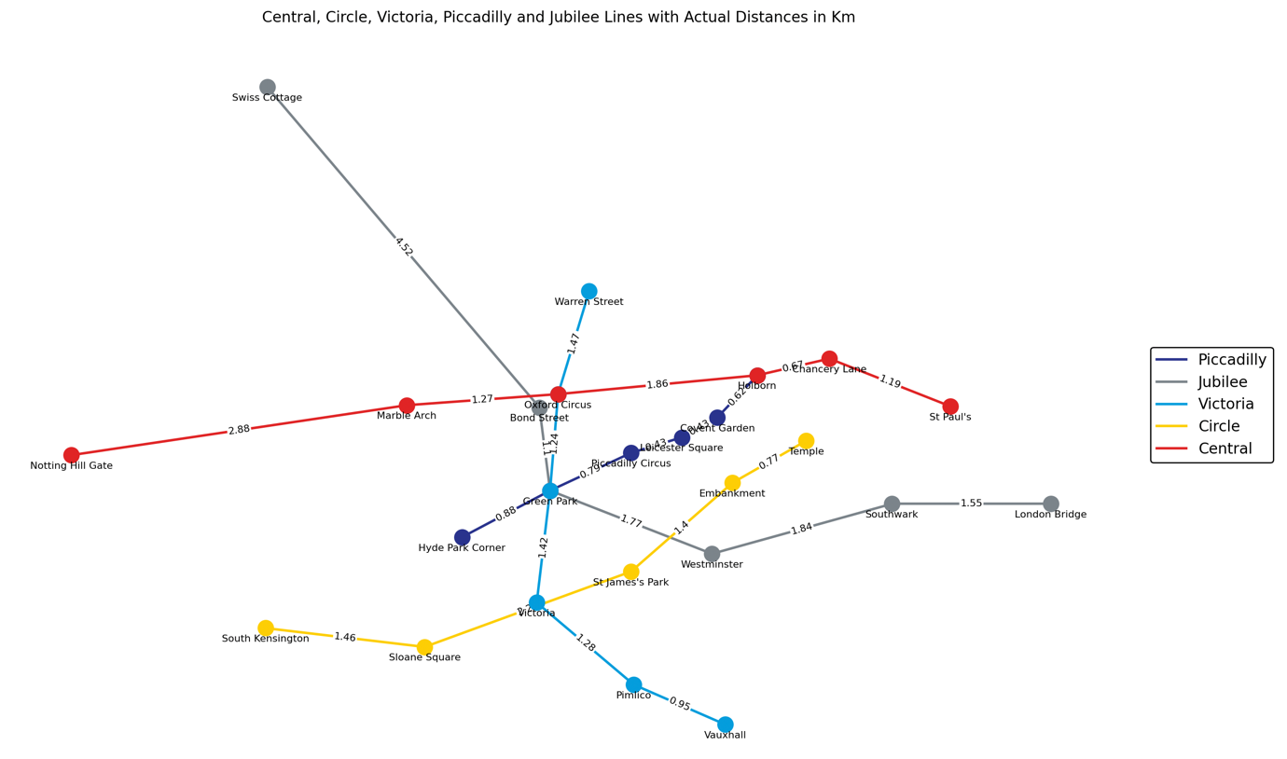

The plot was drawed by using actual positions so the routes looks like on Google Maps

Victoria line

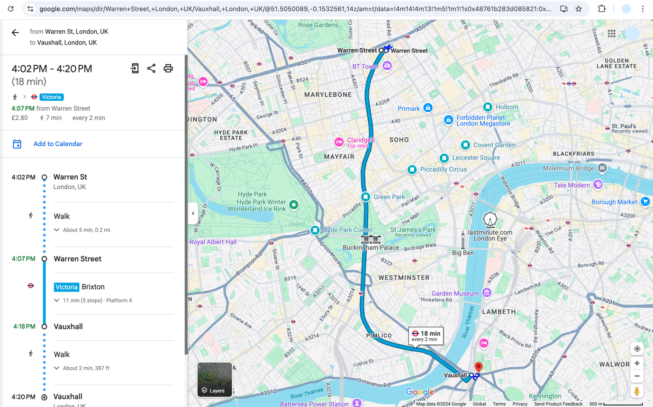

Jubilee line

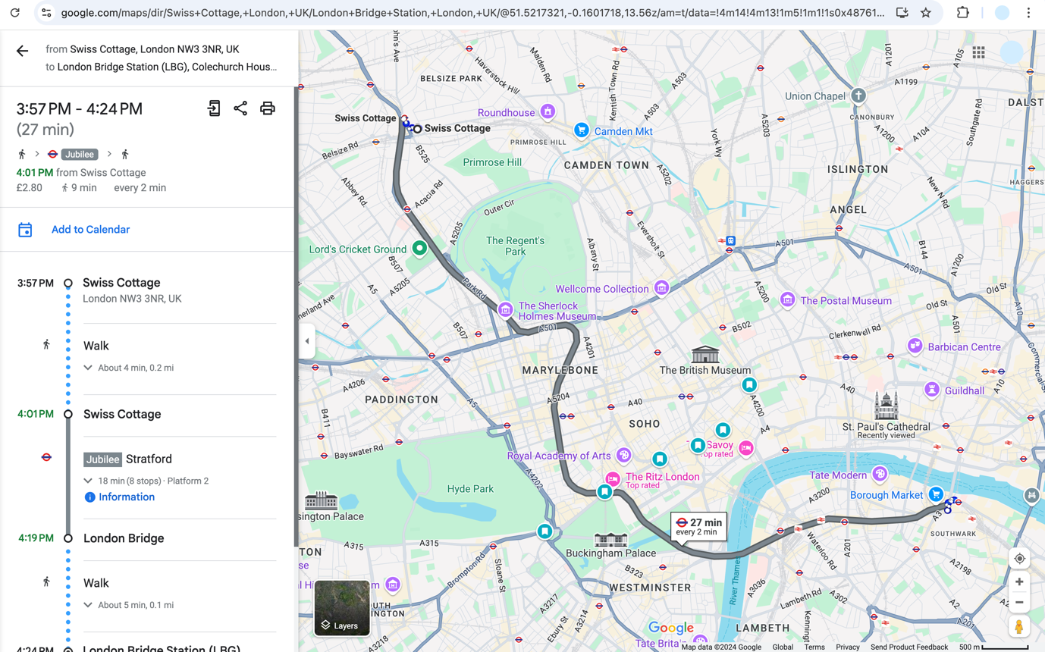

Central line

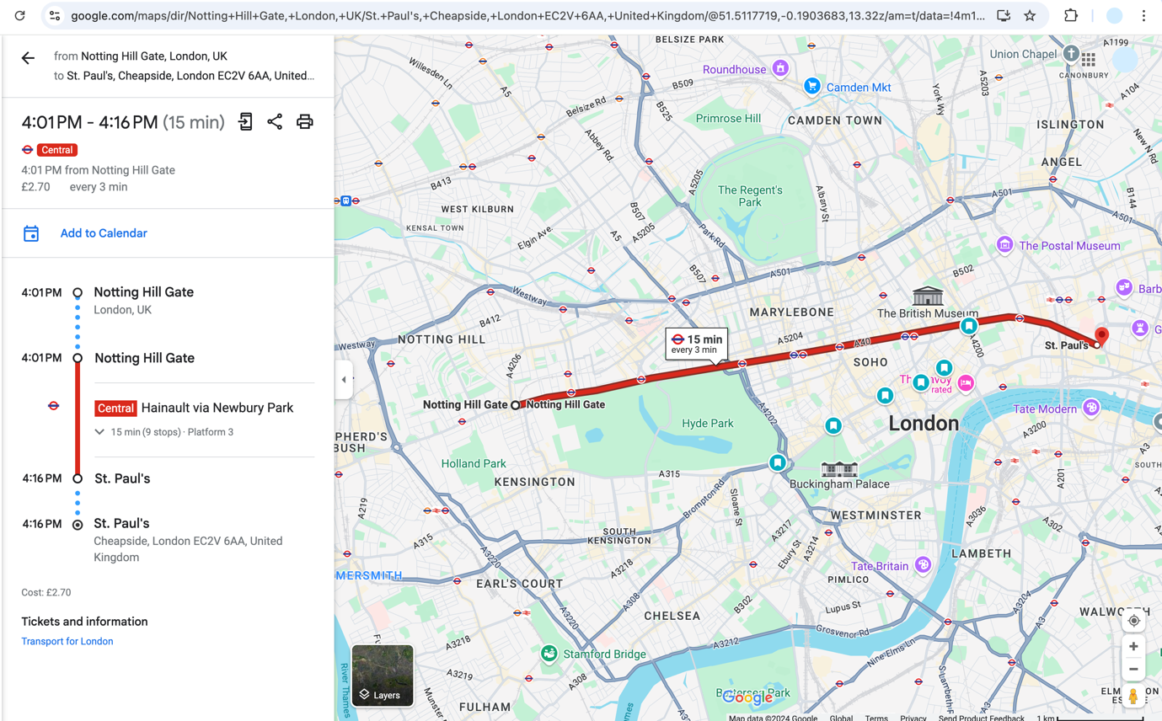

Circle line (District line also has this route)

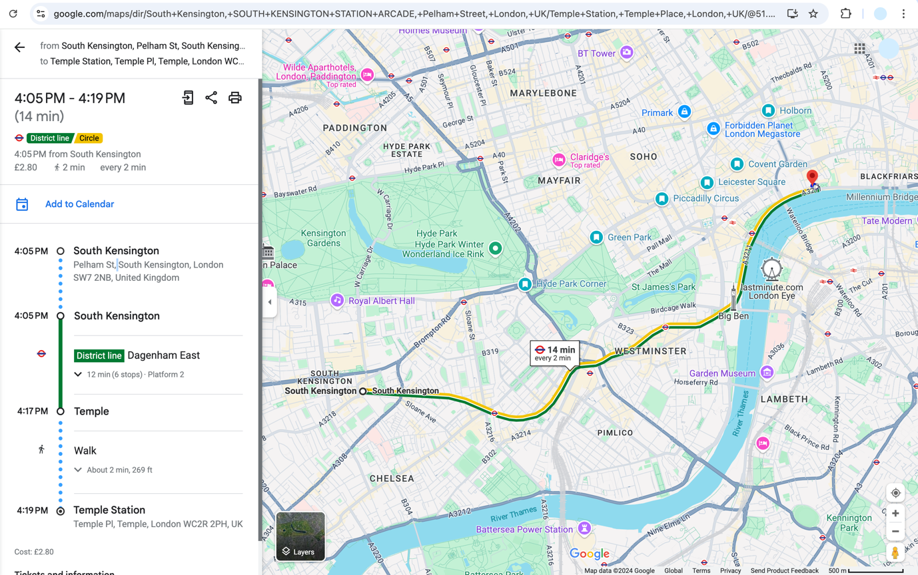

# Task 3

## Code

def **calculate_network_statistics**(G):

*# Extract distances from the graph*

*# This list comprehension iterates over all edges in the graph G,*

*# extracting the 'weight' attribute (which represents distance) for each edge,*

*# and includes it in the distances list only if the weight is not "N/A".*

distances = [d['weight'] for u, v, d in G.edges(data=True) if d['weight'] != "N/A"]

*# Calculate total length of the transport network*

*# The total length is calculated by summing up all the distances in the distances list.*

total_length = **sum**(distances)

*# Calculate the average distance between the stations*

*# The average distance is calculated using NumPy's mean function on the distances list.*

average_distance = np.mean(distances)

*# Calculate the standard deviation of the distances between the stations*

*# The standard deviation is calculated using NumPy's std function on the distances list.*

std_deviation = np.std(distances)

*# Return the calculated statistics as a tuple*

return total_length, average_distance, std_deviation

*# Create the graph and plot*

G, plt = create_combined_segment() *# Call the function to create the graph and plot*

*# Calculate and print the network statistics*

total_length, average_distance, std_deviation = calculate_network_statistics(G) *# Calculate statistics*

**print**(f"Total length of the transport network: {total_length:.2f} km") *# Print total length*

**print**(f"Average distance between the stations: {average_distance:.2f} km") *# Print average distance*

**print**(f"Standard deviation of the distances between the stations: {std_deviation:.2f} km") *# Print standard deviation*

*# Adjust the margins and show the plot*

plt.subplots_adjust(left=0.1, right=0.9, top=0.9, bottom=0.1) *# Adjust plot margins*

plt.tight_layout() *# Automatically adjust subplot parameters to give specified padding*

plt.show() *# Display the plot*

**print**("Distances:" , distances)

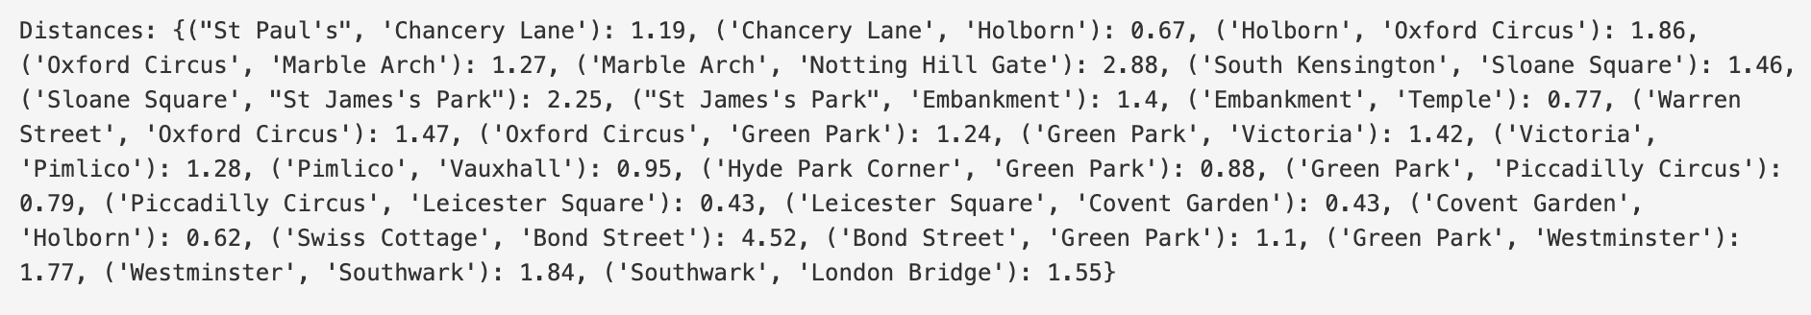

## Explain the math

1. Total Length of the Transport Network

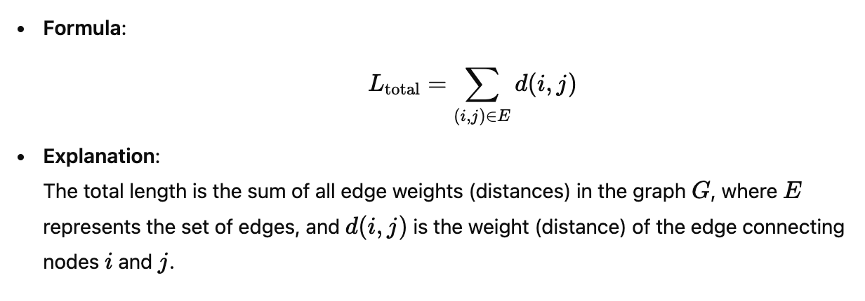

2. Average Distance Between Stations

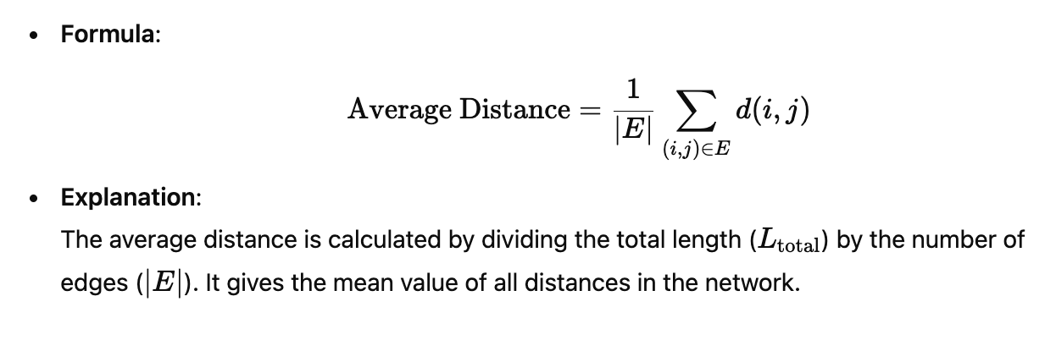

3. Standard Deviation of Distances

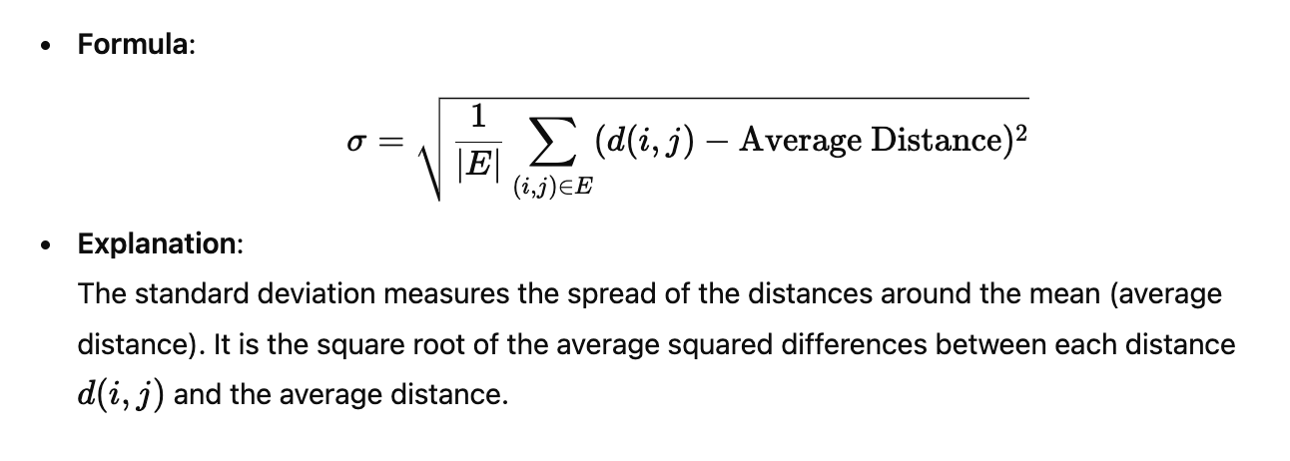

## Result

